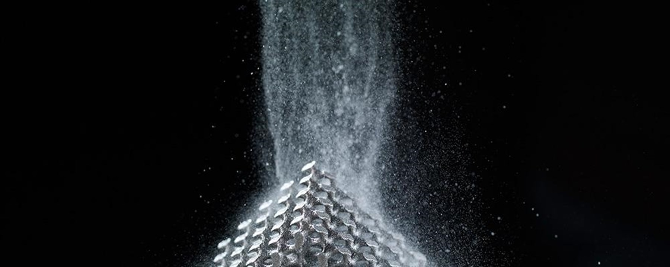
04 June 2024

Materialise and ArcelorMittal Announce Partnership to Enhance Metal 3D Printing Capabilities
- Homepage /
- Media /
- News Articles
Combination of Materialise’s Next-Generation Build Processor and ArcelorMittal Powders AdamIQ™ solutions to increase speed, quality and cost-efficiency for Metal 3D Printing
LEUVEN, Belgium – June 4, 2024 – Materialise, a global leader in 3D printing software and services, and ArcelorMittal Powders, a business unit of ArcelorMittal established to produce high-quality steel powders, have signed a memorandum of understanding (MOU) to create solutions to optimize laser powder bed fusion (LPBF) equipment and metal 3D printing strategies. Through the MOU, ArcelorMittal will use Materialise’s next-gen build processor for 3d printers.
“Our collaboration with Materialise supports our vision that the key to success in additive manufacturing is about finding the right blend of digital instructions and steel powders to deliver the best balance of quality and productivity in an application. Whether developing new applications with new alloys or proving the feasibility of new designs for existing applications through steel additive manufacturing, Materialise offers us a formidable channel to bring build instructions straight to the heart of a 3D printer”, said Aubin Defer, Chief Marketing Officer, ArcelorMittal Powders.
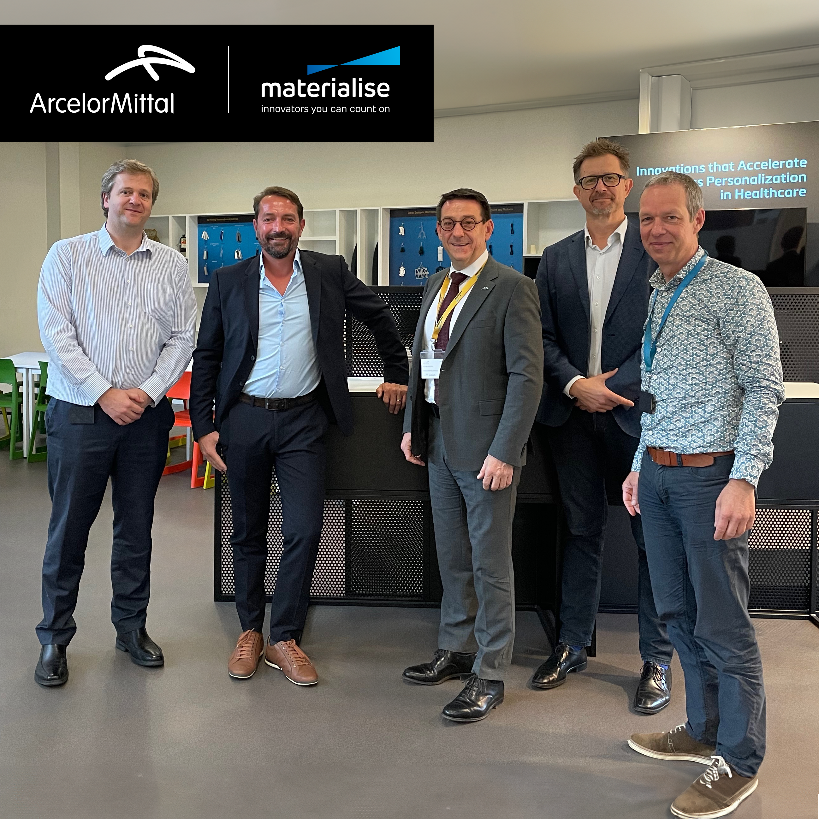
The two companies are partnering to develop solutions that integrate Materialise’s next-gen build processor and ArcelorMittal Powders’ AdamIQTM range of steel powders to enhance LPBF, the most widely used additive manufacturing technology for producing metal parts. Build processors link 3D printers with data preparation software, streamlining the additive manufacturing process from design to print. Materialise’s next-gen build processor supports larger build volumes and more complex geometries than traditional build processors, so users will be able to customize process parameters, streamline workflows and print faster. Combined with the AdamIQTM steel powders made specifically for additive manufacturing applications, these printing solutions help improve setup and production speed, part quality, cost-efficiency, reproducibility and repeatability.
“Our collaboration with ArcelorMittal marks a significant milestone in advancing our shared vision. By enhancing processes and solutions, we aim to expand the applications and industries utilizing additive manufacturing. This partnership brings us closer to a future where 3D printing achieves its full potential, enabling both mass customization and large-scale production,” said Udo Eberlein, Vice President of Software at Materialise.
Materialise has more than 30 years of 3D printing experience and a proven track record for providing build processors. ArcelorMittal Powders combines nearly 20 years of metallurgical expertise to provide steel solutions for additive manufacturing applications.
For photos, please visit: https://www.materialise.com/en/news/press-releases/arcelormittal-partnership-metal-3d-printing

Contact Us

Contact information ArcelorMittal corporate communications
- Emailpress@arcelormittal.com
- Paul Weigh+44 203 214 2419
Sign up for alerts

