MT:NA
↙
€23.47

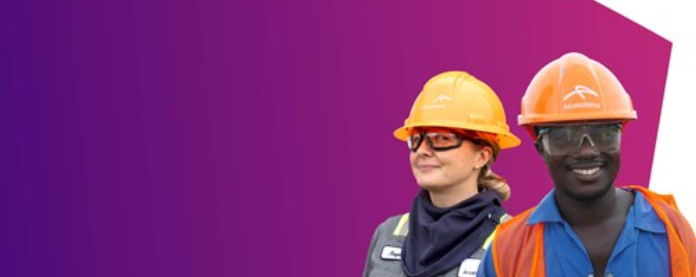
23 April 2024 12:00 CET

ArcelorMittal publishes its 2023 Integrated Annual Review
- Homepage /
- Media /
- Press Releases
Today, ArcelorMittal (‘the company’) published its 2023 Integrated Annual Review (‘IAR’), which can be accessed here annualreview2023.arcelormittal.com.
The 2023 IAR, ‘Preparing for the future’, is structured in nine main chapters:
- Our business and material issues
- Driving change in our safety performance
- Responsible energy use and lower-carbon futures
- Air, water, land, biodiversity and ecosystems
- Delivering a circular economy through innovation
- Value chains our stakeholders trust
- Attracting, retaining and developing our people
- Communities and Just Transition
- Governance and risk management
New disclosures include:
- An update on further work done to evaluate physical and transition climate-related risks and opportunities, aligned with current and upcoming regulation.
- The progress made to better understand our scope 3 emissions and our engagement with suppliers.
- An update on the certification of our sites to leading third party multi-stakeholder ESG standards such as ResponsibleSteel™.
- Progress we have made in advancing our Diversity and Inclusion (D&I) roadmap.
- Our Just Transition framework including the approach and principles for a just transition.
- The EU Taxonomy report where we are reporting “substantial contribution” to climate change mitigation for revenues, capex and opex for the first time.
Commenting Aditya Mittal, CEO, ArcelorMittal, said:
“I recognise that for most people reading the IAR we have published today, safety is likely the most important issue on the agenda. I share this focus. In December 2023, we launched a comprehensive independent safety audit that is expected to deliver findings in the latter part of the year. While we carry out audits on a regular basis, none have been as exhaustive or ambitious in their scale and reach. We recently published a first interim update on the work completed in the independent audit so far.
“The benefits of running assets safely are widespread. The safest assets reflect not only an excellent safety culture, but more broadly a culture of care and attention to every detail, where employees speak up, support each other and work together as a team to embrace opportunities and successfully confront challenges. This is the culture we need across all our operations if we are to deliver on our purpose of 'Smarter steels for people and planet.'
“Continuous investment in our operations is another factor that influences our ability to deliver against our purpose. We have a lot of exciting growth opportunities ahead of us, and this year we will see some major projects coming online.
“Nothing is possible without our people – the 150,000 employed directly in our operations and the additional contractors who join them for specific projects. We have to work purposefully to ensure that we continue to attract the best and brightest talent into our company. We continue to make good progress at embedding our people strategy that is founded on three pillars: developing leadership that inspires excellence; attracting and developing talent to thrive for the future; and engaging all our workforce through implementing our D&I roadmap. Underpinning all three is a culture that motivates and inspires people to make a difference, where they can grow both professionally and personally, and where they can develop new ideas and succeed.
“As this review makes clear, there is a great deal of activity underway as ArcelorMittal continues to evolve, adapt and progress to ensure future success.”
Commenting, Lakshmi Mittal, Executive Chairman, ArcelorMittal, said:
“Our Integrated Annual Review aims to provide our stakeholders with a clear understanding of how we manage our business, and how we seek to build and protect value in a sustainable and responsible way. We provide an overview of the company’s performance, against our broader strategic objectives and against our sustainability goals. We seek to highlight the most material issues to our stakeholders, and how we are addressing the risks and opportunities presented to us, both now and in the longer term. The review takes account of our focus on safety, our progress on decarbonisation, our people values, how we aim to work with our local communities, our engagement with our value chain, and our growing efforts to work sustainably within the natural environment.
This year we have continued to progress with developing and investing in the breakthrough technologies for our sector and with our decarbonisation programme, and with preparing for reporting against new sustainability legislations. We have also been advancing on our diversity and inclusion (D&I) roadmap, aimed at building mutual engagement, delivering a flow of new ideas, and increasing productivity to enable a high-performing organisation.”

Contact Us

Contact information ArcelorMittal investor relations
- General:+44 207 543 1128
- Retail:+44 203 214 2893
- SRI:+44 203 214 2801
- Bonds/Credit:+33 1 71 92 1026

Contact information ArcelorMittal corporate communications
- Email:press@arcelormittal.com
- Paul Weigh+44 203 214 2419
About ArcelorMittal
ArcelorMittal is one of the world’s leading integrated steel and mining companies with a presence in 60 countries and primary steelmaking operations in 15 countries. It is the largest steel producer in Europe, among the largest in the Americas, and has a growing presence in Asia through its joint venture AM/NS India. ArcelorMittal sells its products to a diverse range of customers including the automotive, engineering, construction and machinery industries, and in 2023 generated revenues of $68.3 billion, produced 58.1 million metric tonnes of crude steel and, 42.0 million tonnes of iron ore. Our purpose is to produce smarter steels for people and planet. Steels made using innovative processes which use less energy, emit significantly less carbon and reduce costs. Steels that are cleaner, stronger and reusable. Steels for the renewable energy infrastructure that will support societies as they transform through this century. With steel at our core, our inventive people and an entrepreneurial culture at heart, we will support the world in making that change. ArcelorMittal is listed on the stock exchanges of New York (MT), Amsterdam (MT), Paris (MT), Luxembourg (MT) and on the Spanish stock exchanges of Barcelona, Bilbao, Madrid and Valencia (MTS).

