La Granda (Gozón), 10 May 2024
- The construction of the electric arc furnace (EAF), which will transform the existing steel shop at the Gijón plant, represents an investment of €213 million.
- The new facility will have an annual production capacity of 1.1 million tonnes of semi-finished steel products, which will be supplied to the rail and wire-rod mills at the plant.
- Initially, steel production through the new EAF will lead to a reduction in CO₂ emissions of over 35%; the reduction in emissions could reach 1 million tonnes of CO₂ equivalent a year once the transition phase has been completed.
ArcelorMittal has started the construction of an electric arc furnace (EAF) for long products at its Gijón plant, which is expected to produce its first heat in the first quarter of 2026. This investment of €213 million will be the first major EAF project to be implemented within the company’s decarbonisation programme in Europe and will constitute the first step towards low-carbon emissions steelmaking in Asturias.
The reduction in CO₂ emissions is achieved by transitioning from a process in which the main raw material was hot metal produced in the blast furnace using fossil fuels, to a process where the main inputs are scrap and direct reduced iron and which uses electricity which will be generated from wind and solar power, when available. In the first stage, steel production through the new EAF will lead to a reduction in CO₂ emissions of over 35%; this reduction in emissions could reach 1 million tonnes of CO₂ equivalent a year once the transition phase has been completed.
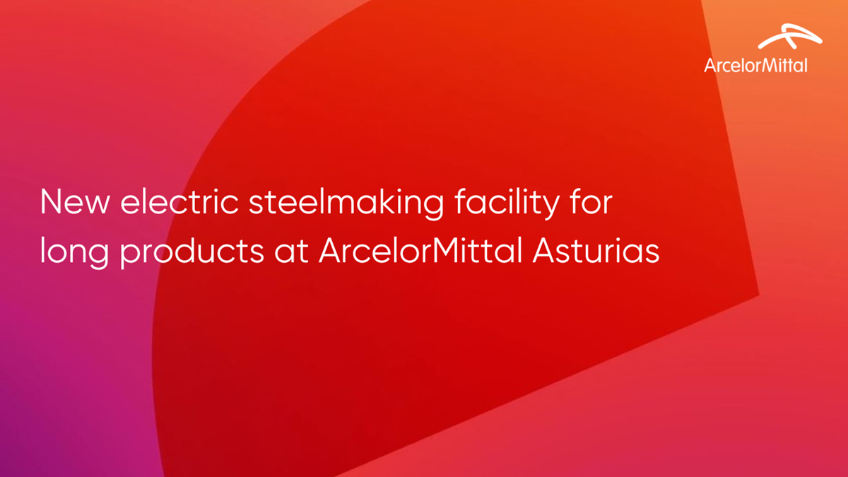
This project places the Long Products division in Asturias at the forefront of decarbonisation in Europe, as it is the first large investment undertaken as part of ArcelorMittal’s decarbonisation programme on this continent. The installation of this state-of-the-art technology will enable ArcelorMittal to produce high added value rails and wire rod, through a process that incorporates the highest safety standards.
The ground-breaking ceremony, which took place at ArcelorMittal Asturias’ plant in the municipality of Gijón, was attended by the President of the Government of the Principality of Asturias, Adrián Barbón; the Special Commissioner at the Ministry of Industry for the PERTE (Strategic Project for Economic Recovery and Transformation) for Industrial Decarbonisation, Luis Ángel Colunga; and the Mayor of Gijón, Carmen Moriyón, among other authorities.
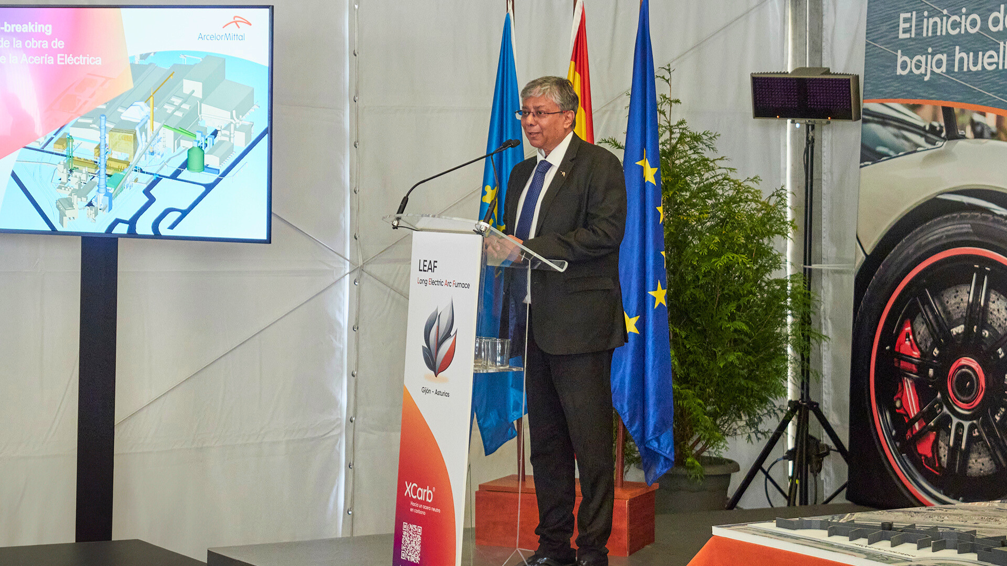
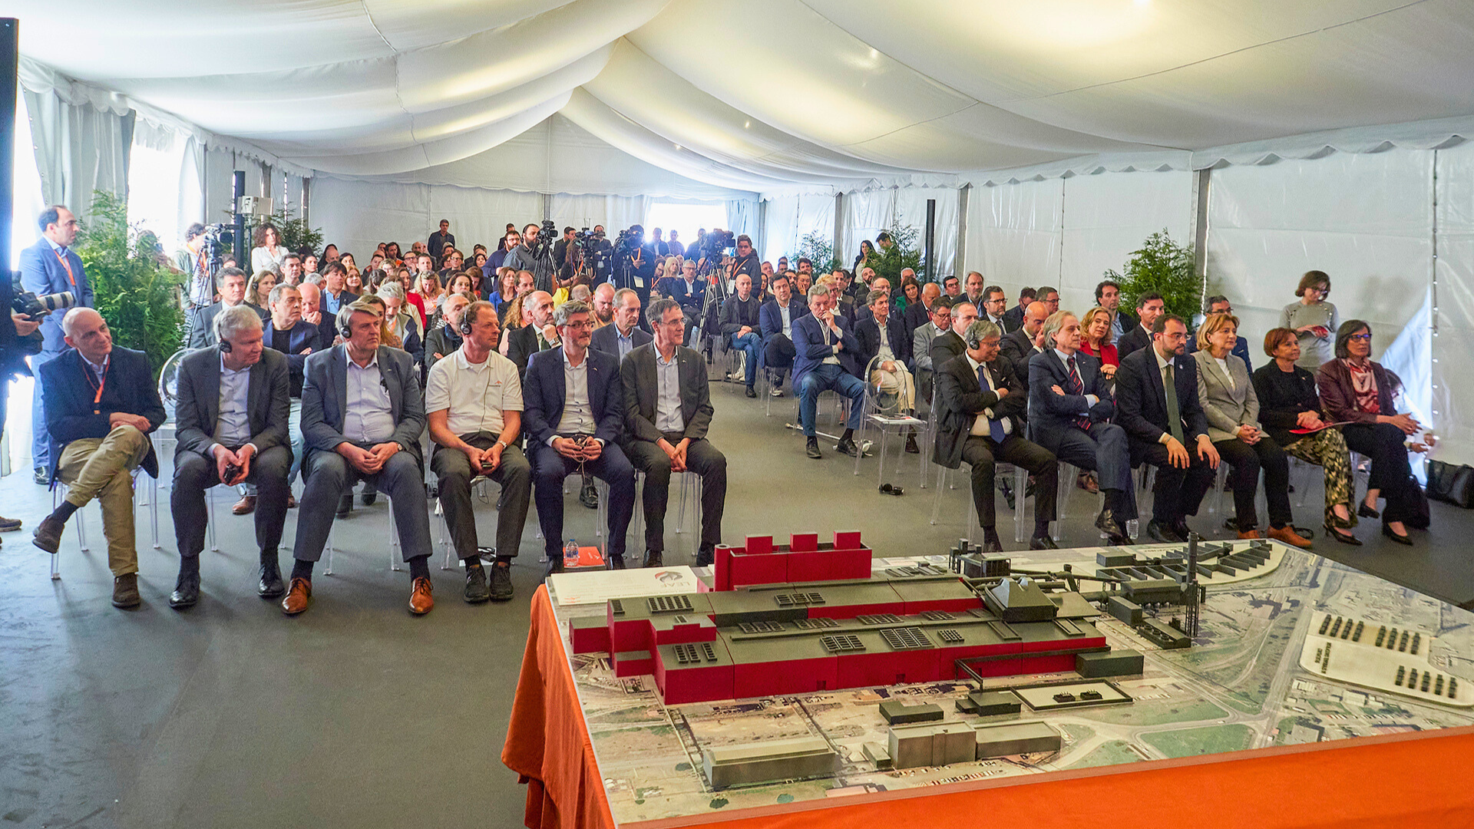
Speaking at the event, Sanjay Samaddar, CEO of ArcelorMittal Europe – Long Products, said: “This investment will lead to the implementation in Gijón of the latest technology for electric arc furnaces and will contribute to our ability to meet the growing demand for low-carbon emissions rails and wire rod from our customers in the automotive, construction and rail infrastructure sectors, among others; particularly in sectors with stringent carbon criteria for public procurement contracts.”
Philippe Meyran, CEO of the Asturias Cluster, which includes the plants in Asturias, Etxebarri, Lesaka and Sagunto, expressed his appreciation for the support received from all the stakeholders involved in the project: “We have achieved this milestone thanks to the support of the public Administrations, of our customers, of our partners, of the entire project team… We are progressing towards our goal to have a more sustainable industry in here in Asturias.”

