Materialise Reports First Quarter 2024 Results
KC
Kaitlin Cottone






Do 25/04/2024 12:48

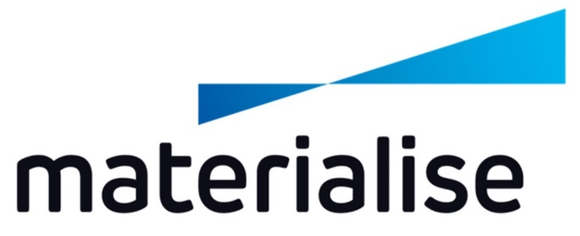

Materialise Reports First Quarter 2024 Results
LEUVEN, Belgium--(BUSINESS WIRE)—April 25, 2024 -- Materialise NV (NASDAQ:MTLS), a leading provider of additive manufacturing and medical software and of sophisticated 3D printing services, today announced its financial results for the first quarter ended March 31, 2024.
Highlights – First Quarter 2024
- Total revenue decreased by 3.4% to 63,637 kEUR compared to 65,886 kEUR for the first quarter of 2023.
- Gross profit as a percentage of revenue increased to 56.5% for the first quarter of 2024 from 55.9% for the 2023 period.
- Adjusted EBIT decreased to 2,656 kEUR for the first quarter of 2024 from 4,998 kEUR for the 2023 period while Adjusted EBITDA decreased to 8,094 kEUR for the first quarter of 2024 from 10,310 kEUR for the 2023 period.
- Net profit for the first quarter of 2024 was 3,585 kEUR, or 0.06 EUR per diluted share, compared to 3,715 kEUR, or 0.06 EUR per diluted share, for the 2023 period.

CEO Brigitte de Vet-Veithen commented, “In line with expectations our consolidated revenue decreased by 3% compared to the same period of 2023, an exceptionally strong quarter which showed 24% growth. In the first quarter of 2024, our Materialise Medical segment continued to lead the way with 8% revenue growth, while revenue declined in our Manufacturing and Software segments amidst less favorable market conditions. While continued investments in sustainable growth and the ongoing conversion to a recurring revenue business model impacted our operational profitability, we delivered a positive net result and an improved net cash position.”

First Quarter 2024 Results
Total revenue for the first quarter of 2024 decreased 3.4% to 63,637 kEUR from 65,886 kEUR for the first quarter of 2023. Adjusted EBIT decreased to 2,656 kEUR for the first quarter of 2024 from 4,998 kEUR for the 2023 period. The Adjusted EBIT margin (Adjusted EBIT divided by total revenue) for the first quarter of 2024 was 4.2%, compared to 7.6% for the first quarter of 2023. Adjusted EBITDA decreased to 8,094 kEUR for the first quarter of 2024 from 10,310 kEUR for the 2023 period.
Revenue from our Materialise Medical segment increased 7.7% to 26,183 kEUR for the first quarter of 2024 compared to 24,317 kEUR for the same period in 2023. Segment Adjusted EBITDA increased to 7,921 kEUR for the first quarter of 2024 compared to 7,348 kEUR while the segment Adjusted EBITDA margin remained stable at 30.3% compared to 30.2% for the first quarter of 2023.
Revenue from our Materialise Software segment decreased by 8.0% to 10,438 kEUR for the first quarter of 2024 from 11,350 kEUR for the same quarter last year. Segment Adjusted EBITDA decreased to 1,090 kEUR from 2,427 kEUR while the segment Adjusted EBITDA margin was 10.4% compared to 21.4% for the prior-year period.
Revenue from our Materialise Manufacturing segment decreased by 10.6% to 27,016 kEUR for the first quarter of 2024 from 30,219 kEUR for the first quarter of 2023. Segment Adjusted EBITDA decreased to 1,529 kEUR from 3,189 kEUR while the segment Adjusted EBITDA margin was 5.7% compared to 10.6% for the first quarter of 2023.
Gross profit decreased to 35,935 kEUR compared to 36,837 kEUR for the same period last year, while gross profit as a percentage of revenue increased to 56.5% compared to 55.9% for the first quarter of 2023.
Research and development (“R&D”), sales and marketing (“S&M”) and general and administrative (“G&A”) expenses increased, in the aggregate, 5.5% to 34,138 kEUR for the first quarter of 2024 from 32,358 kEUR for the first quarter of 2023.
Net other operating income increased to 789 kEUR from 519 kEUR for the first quarter of 2023.
Operating result amounted to 2,585 kEUR compared to 4,998 kEUR for the first quarter of 2023.
Net financial result increased to 1,510 kEUR compared to (566) kEUR for the first quarter of 2023.
The first quarter of 2024 contained income tax expenses of (510) kEUR, compared to (718) kEUR in the first quarter of 2023.
As a result of the above, net profit for the first quarter of 2024 was 3,585 kEUR, compared to 3,715 kEUR for the same period in 2023. Total comprehensive income for the first quarter of 2024, which includes exchange differences on translation of foreign operations, was 3,312 kEUR compared to 4,490 kEUR for the 2023 period.
At March 31, 2024, we had cash and cash equivalents of 128,899 kEUR compared to 127,573 kEUR at December 31, 2023. Gross debt amounted to 59,686 kEUR, compared to 64,398 kEUR at December 31, 2023. As a result, our net cash position (gross debt less cash and cash equivalents) increased by 6,038 kEUR to 69,213 kEUR.
Cash flow from operating activities for the first quarter of 2024 decreased to 9,970 kEUR from 11,044 kEUR for the same period in 2023. Total cash out from capital expenditures for the first quarter of 2024 amounted to 2,830 kEUR.
Net shareholders’ equity at March 31, 2024 was 239,977 kEUR compared to 236,594 kEUR at December 31, 2023.
2024 Guidance

Mrs. de Vet-Veithen concluded, “The fundamentals of our three business segments are strong and we remain confident that we are well positioned to deliver on our growth objectives. We continue to expect to report consolidated revenue for the full fiscal year 2024 within the 265,000 to 275,000 kEUR range we communicated in our year-end 2023 earnings announcement in February 2024. We are also maintaining our Adjusted EBIT guidance of 11,000 kEUR to 14,000 kEUR for fiscal year 2024.”

Non-IFRS Measures
Materialise uses EBIT, EBITDA, Adjusted EBIT and Adjusted EBITDA as supplemental financial measures of its financial performance. EBIT is calculated as net profit plus income taxes, financial expenses (less financial income) and shares of profit or loss in a joint venture. EBITDA is calculated as net profit plus income taxes, financial expenses (less financial income), shares of profit or loss in a joint venture and depreciation and amortization. Adjusted EBIT and Adjusted EBITDA are determined by adding share-based compensation expenses, acquisition-related expenses of business combinations, impairments and revaluation of fair value due to business combinations to EBIT and EBITDA, respectively. Management believes these non-IFRS measures to be important measures as they exclude the effects of items which primarily reflect the impact of financing decisions and, in the case of EBITDA and Adjusted EBITDA, long term investment, rather than the performance of the company’s day-to-day operations. The company also uses segment Adjusted EBITDA to evaluate the performance of its three business segments. As compared to net profit, these measures are limited in that they do not reflect the cash requirements necessary to service interest or principal payments on the company’s indebtedness and, in the case of EBITDA and Adjusted EBITDA, these measures are further limited in that they do not reflect the periodic costs of certain capitalized tangible and intangible assets used in generating revenues in the company’s business, or the changes associated with impairments. Management evaluates such items through other financial measures such as financial expenses, capital expenditures and cash flow provided by operating activities. The company believes that these measurements are useful to measure a company’s ability to grow or as a valuation measurement. The company’s calculation of EBIT, EBITDA, Adjusted EBIT and Adjusted EBITDA may not be comparable to similarly titled measures reported by other companies. EBIT, EBITDA, Adjusted EBIT and Adjusted EBITDA should not be considered as alternatives to net profit or any other performance measure derived in accordance with IFRS. The company’s presentation of EBIT, EBITDA, Adjusted EBIT and Adjusted EBITDA should not be construed to imply that its future results will be unaffected by unusual or non-recurring items.
Exchange Rate
This document contains translations of certain euro amounts into U.S. dollars at specified rates solely for the convenience of readers. Unless otherwise noted, all translations from euros to U.S. dollars in this document were made at a rate of EUR 1.00 to USD 1.0811, the reference rate of the European Central Bank on March 28, 2024.
Conference Call and Webcast
Materialise will hold a conference call and simultaneous webcast to discuss its financial results for the first quarter of 2024 on Thursday, April 25, 2024, at 8:30 a.m. ET/2:30 p.m. CET. Company participants on the call will include Brigitte de Vet-Veithen, Chief Executive Officer and Koen Berges, Chief Financial Officer. A question-and-answer session will follow management’s remarks.
To access the call by phone, please click the link below at least 15 minutes prior to the scheduled start time and you will be provided with dial-in details. Participants can choose to dial in or receive a call to connect to Materialise’s conference call.

- https://register.vevent.com/register/BIb413a8f0638448a2b9b49116612e00d9

The conference call will also be broadcast live over the Internet with an accompanying slide presentation, which can be accessed on the company’s website at [about%3Ablank]http://investors.materialise.com. A webcast of the conference call will be archived on the company's website for one year.
About Materialise
Materialise incorporates over 30 years of 3D printing experience into a range of software solutions and 3D printing services, which form the backbone of the 3D printing industry. Materialise’s open and flexible solutions enable players in a wide variety of industries, including healthcare, automotive, aerospace, art and design, and consumer goods, to build innovative 3D printing applications that aim to make the world a better and healthier place. Headquartered in Belgium, with branches worldwide, Materialise combines one of the largest groups of software developers in the industry with one of the largest and most complete 3D printing facilities in the world. For additional information, please visit: www.materialise.com.
Cautionary Statement on Forward-Looking Statements
This press release contains forward-looking statements within the meaning of Section 27A of the Securities Act of 1933, as amended, and Section 21E of the Securities Exchange Act of 1934, as amended, regarding, among other things, our intentions, beliefs, assumptions, projections, outlook, analyses or current expectations, plans, objectives, strategies and prospects, both financial and business, including statements concerning, among other things, our estimates for the current fiscal year’s revenue and Adjusted EBIT, our results of operations, cash needs, capital expenditures, expenses, financial condition, liquidity, prospects, growth and strategies (including how our business, results of operations and financial condition could be impacted by the current armed conflicts in the Middle East and Ukraine and governmental responses thereto, inflation, increased labor, energy and materials costs), and the trends and competition that may affect the markets, industry or us. Such statements are subject to known and unknown uncertainties and risks. When used in this press release, the words “estimate,” “expect,” “anticipate,” “project,” “plan,” “intend,” “believe,” “forecast,” “will,” “may,” “could,” “might,” “aim,” “should,” and variations of such words or similar expressions are intended to identify forward-looking statements. These forward-looking statements are based upon the expectations of management under current assumptions at the time of this press release. These expectations, beliefs and projections are expressed in good faith and the company believes there is a reasonable basis for them. However, the company cannot offer any assurance that our expectations, beliefs and projections will actually be achieved. By their nature, forward-looking statements involve risks and uncertainties because they relate to events, competitive dynamics and industry change, and depend on economic circumstances that may or may not occur in the future or may occur on longer or shorter timelines than anticipated. We caution you that forward-looking statements are not guarantees of future performance and involve known and unknown risks, uncertainties and other factors that are in some cases beyond our control. All of the forward-looking statements are subject to risks and uncertainties that may cause the company's actual results to differ materially from our expectations, including risk factors described in the company's most recent annual report on Form 20-F filed with the U.S. Securities and Exchange Commission. There are a number of risks and uncertainties that could cause the company's actual results to differ materially from the forward-looking statements contained in this press release.
The company is providing this information as of the date of this press release and does not undertake any obligation to update any forward-looking statements contained in this press release as a result of new information, future events or otherwise, unless it has obligations under the federal securities laws to update and disclose material developments related to previously disclosed information.

Consolidated income statements (Unaudited)

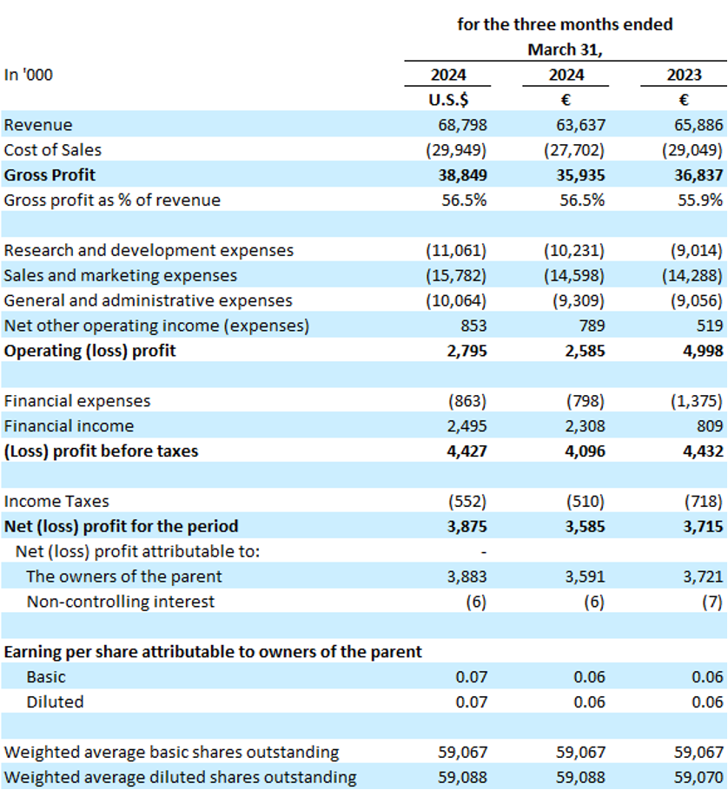
Consolidated statements of comprehensive income (Unaudited)
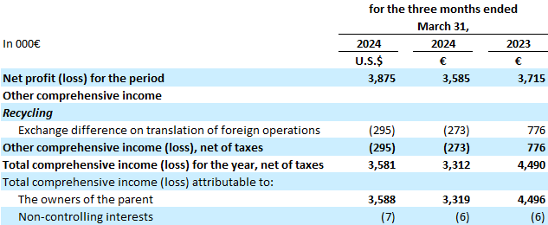
Consolidated statement of financial position (Unaudited)
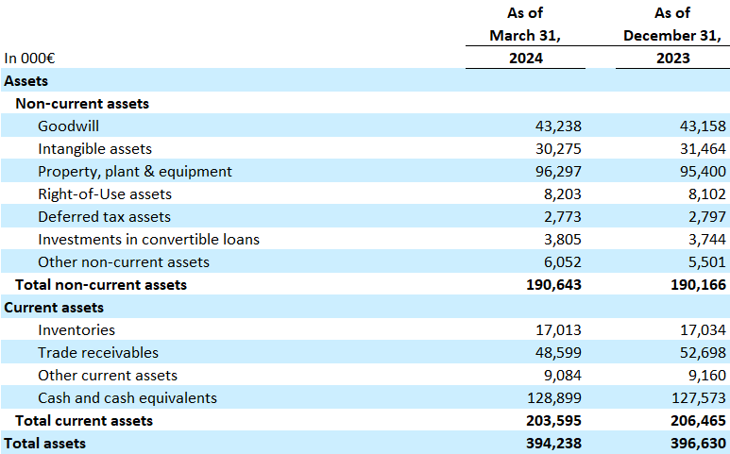
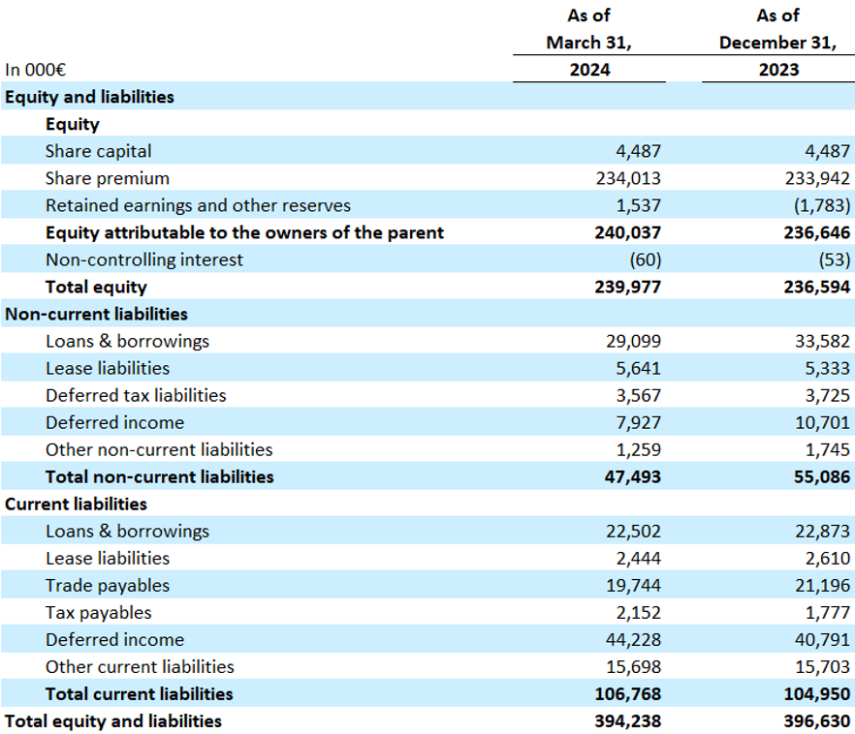
Consolidated statement of cash flows (Unaudited)
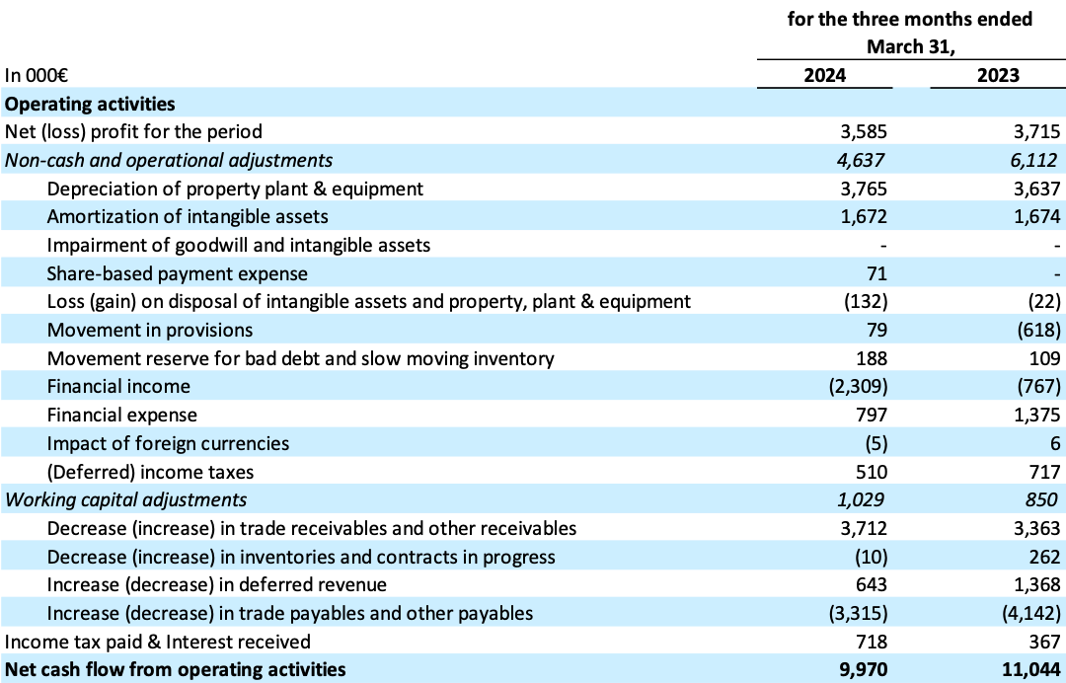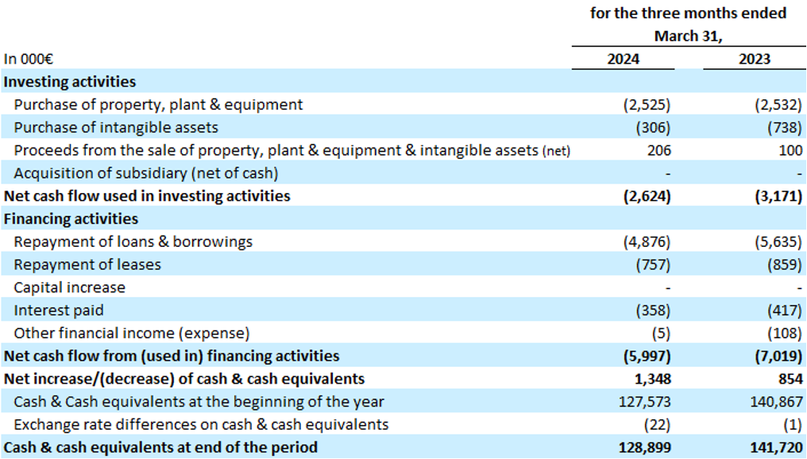
Reconciliation of Net Profit (Loss) to EBIT and Adjusted EBIT (Unaudited)
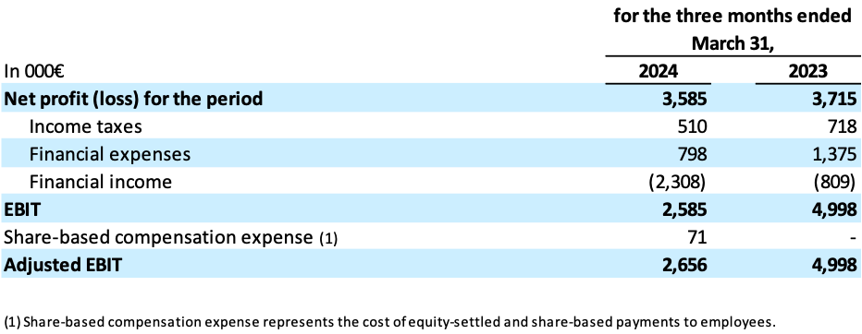
Reconciliation of Net Profit (Loss) to EBITDA and Adjusted EBITDA (Unaudited)
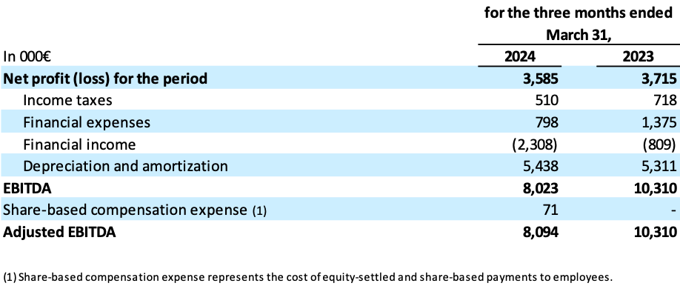
Segment P&L (Unaudited)
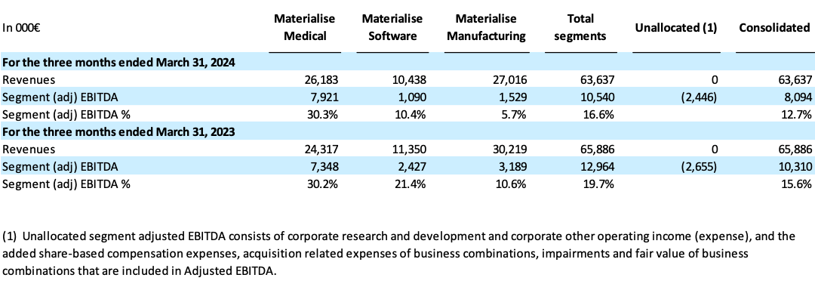
Reconciliation of Net Profit (Loss) to Segment adjusted EBITDA (Unaudited)
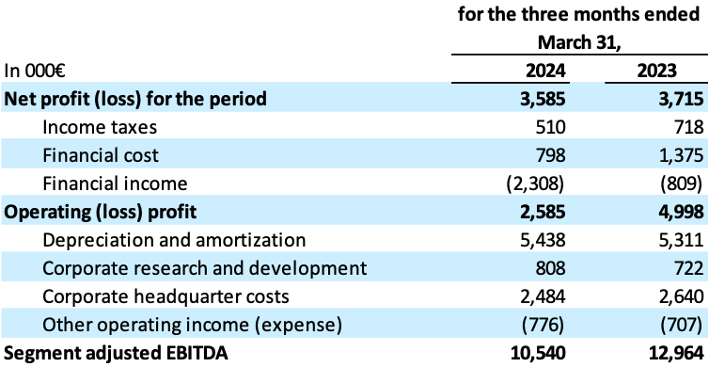
BeantwoordenAllen beantwoordenDoorsturen
Deelvenster Genodigden gesloten

